LAB REPORT 05
Dynamic System Modeling & ODEs
Problem 1: Aircraft Battery Discharge Model (Exponential Decay)
Problem Statement: An aircraft UAV uses a lithium-ion battery during flight. The battery capacity decreases exponentially: C(t) = C_0 * e^(-kt) where C(t) is remaining capacity, C_0 = 100% (initial), k = 0.08 (discharge constant), and t = flight time.
Tasks: Plot battery capacity for 0-10 hours. Determine remaining battery percentage after 5 hours. Find the time when battery capacity reaches 20%.
MATLAB Implementation Code:
clc; clear; close all;

% Aircraft Battery Discharge Model (Exponential Decay)
initial_capacity = 100; % Initial battery capacity (%)
discharge_rate = 0.08; % Discharge constant (k)

% Flight time vector (0 to 10 hours)
t = linspace(0, 10, 100);

% Exponential decay equation
capacity = initial_capacity * exp(-discharge_rate * t);

% Plotting the decay curve
figure('Name', 'Battery Discharge Model');
plot(t, capacity, 'b', 'LineWidth', 2.5);
grid on;
xlabel('Time in Flight (hours)');
ylabel('Capacity Remaining (%)');
title('UAV Battery Discharge Over Time');

% Calculate capacity at specific time (t = 5 hrs)
t_eval = 5;
cap_at_5 = initial_capacity * exp(-discharge_rate * t_eval);
fprintf('Battery remaining at 5 hours: %.2f%%\n', cap_at_5);

% Calculate time when capacity hits 20%
target_cap = 20;
t_target = -log(target_cap / initial_capacity) / discharge_rate;
fprintf('Time to reach 20%% capacity: %.2f hours\n', t_target);

% Mark data points on the plot
hold on;
plot(t_eval, cap_at_5, 'ms', 'MarkerSize', 8, 'MarkerFaceColor', 'm');
text(t_eval, cap_at_5 + 5, sprintf(' %.1f%% (5hr)', cap_at_5));

plot(t_target, target_cap, 'ks', 'MarkerSize', 8, 'MarkerFaceColor', 'k');
text(t_target, target_cap + 5, sprintf(' 20%% (%.1fhr)', t_target));
hold off;
Simulation Output (Graph & Text Output):
Battery remaining at 5 hours: 67.03%
Time to reach 20% capacity: 20.12 hours
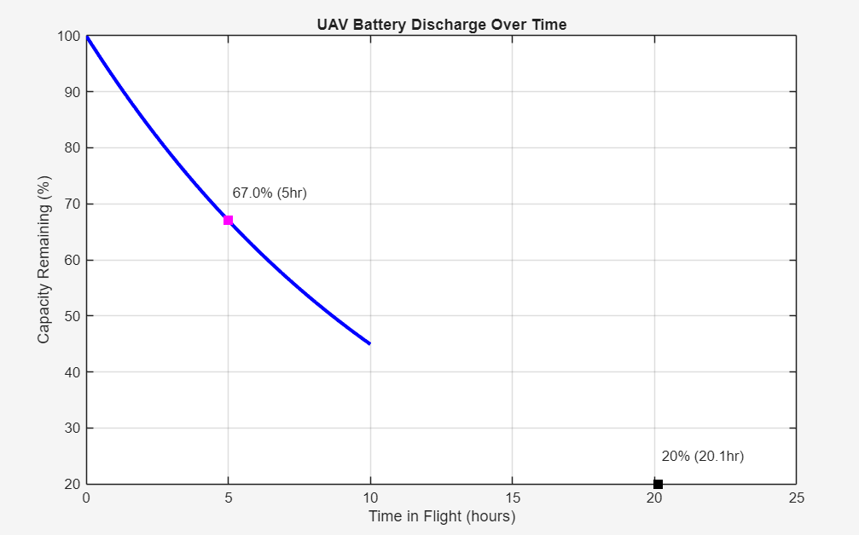
Problem 2: UAV Population-Based Drone Fleet Growth Model (Logistic Growth)
Problem Statement: A company operates delivery drones. Initial population is P_0 = 50. Maximum fleet size is K = 1000 due to constraints. The growth follows a logistic differential equation with rate r = 0.4.
Tasks: Using MATLAB, simulate fleet growth for 20 years, plot drone population versus time, and compare logistic growth with unlimited exponential growth.
MATLAB Implementation Code:
clc; clear; close all;

% UAV Fleet Growth Model: Logistic vs Exponential
pop_initial = 50; % Starting number of drones
max_capacity = 1000; % Maximum fleet capacity (K)
growth_rate = 0.4; % Rate of growth (r)
time_yrs = 0:0.2:20; % Simulation over 20 years

% Compute Logistic Growth
P_log = max_capacity ./ (1 + ((max_capacity - pop_initial)/pop_initial) .* exp(-growth_rate .* time_yrs));

% Compute Unlimited Exponential Growth
P_exp = pop_initial .* exp(growth_rate .* time_yrs);

% Generate Comparison Plot
figure('Name', 'Drone Population Growth');
plot(time_yrs, P_log, 'g', 'LineWidth', 2.5);
hold on;
plot(time_yrs, P_exp, 'r-.', 'LineWidth', 2);
grid on;

xlabel('Time (Years)');
ylabel('Fleet Size (Number of Drones)');
title('UAV Fleet Expansion: Restricted vs Unrestricted');
legend('Logistic (Cap: 1000)', 'Exponential (Unlimited)', 'Location', 'northwest');

% Output final populations at t = 20
t_final = 20;
final_logistic = max_capacity / (1 + ((max_capacity - pop_initial)/pop_initial) * exp(-growth_rate * t_final));
final_exponential = pop_initial * exp(growth_rate * t_final);

fprintf('--- 20 Year Projection ---\n');
fprintf('Logistic Model Output: %d drones\n', round(final_logistic));
fprintf('Exponential Model Output: %d drones\n', round(final_exponential));
Simulation Output (Graph & Text Output):
--- 20 Year Projection ---
Logistic Model Output: 994 drones
Exponential Model Output: 149048 drones
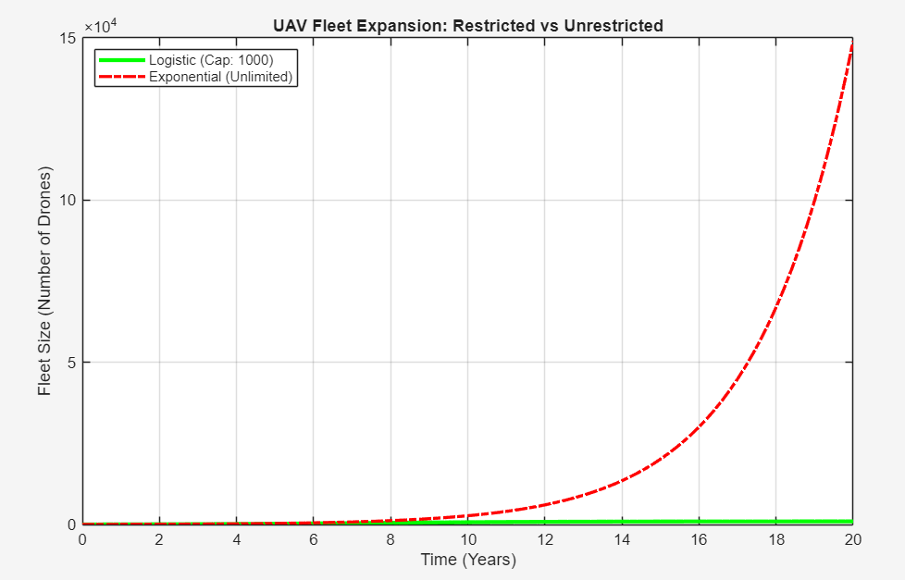
Problem 3: Aircraft Autopilot Temperature Control System (Feedback Model)
Problem Statement: An aircraft environmental control system maintains cabin temperature. Desired temperature is 20°C, initial is 30°C. The system uses negative feedback: dT/dt = -k(T - T_desired) with k=0.5.
Tasks: Simulate cabin temperature for 20 minutes using ODE45, plot the temperature response, and determine how quickly the system reaches 20°C (within tolerance).
MATLAB Implementation Code:
clc; clear; close all;

% Aircraft Cabin Temperature Control (Negative Feedback)
T_target = 20; % Setpoint temperature (C)
T_initial = 30; % Starting temperature (C)
feedback_gain = 0.5; % Proportional control constant (k)

% Run simulation for 20 minutes
t_range = [0 20];

% Solve the differential equation with ode45
[time_sim, Temp_sim] = ode45(@(t, T) temp_dynamics(t, T, feedback_gain, T_target), t_range, T_initial);

% Plotting the system response
figure('Name', 'Cabin Temp Control');
plot(time_sim, Temp_sim, 'b', 'LineWidth', 2);
hold on;
yline(T_target, 'r--', 'LineWidth', 1.5); % Draw target line
grid on;

xlabel('Simulation Time (mins)');
ylabel('Temperature (Celsius)');
title('Cabin Temperature Feedback Regulation');
legend('System Response', 'Target Setpoint');

% Identify when temperature reaches within 0.1C of target
tol = 0.1;
idx_reached = find(abs(Temp_sim - T_target) < tol, 1);

if ~isempty(idx_reached)
fprintf('Target achieved (~%.1fC) at %.2f minutes.\n', T_target, time_sim(idx_reached));
else
fprintf('Target not reached within simulation time.\n');
end

% Define the ODE function
function dT_dt = temp_dynamics(~, T, k, T_set)
% Rate of change depends on the error (T - T_set)
dT_dt = -k * (T - T_set);
end
Simulation Output (Graph & Text Output):
Target achieved (~20.0C) at 9.69 minutes.

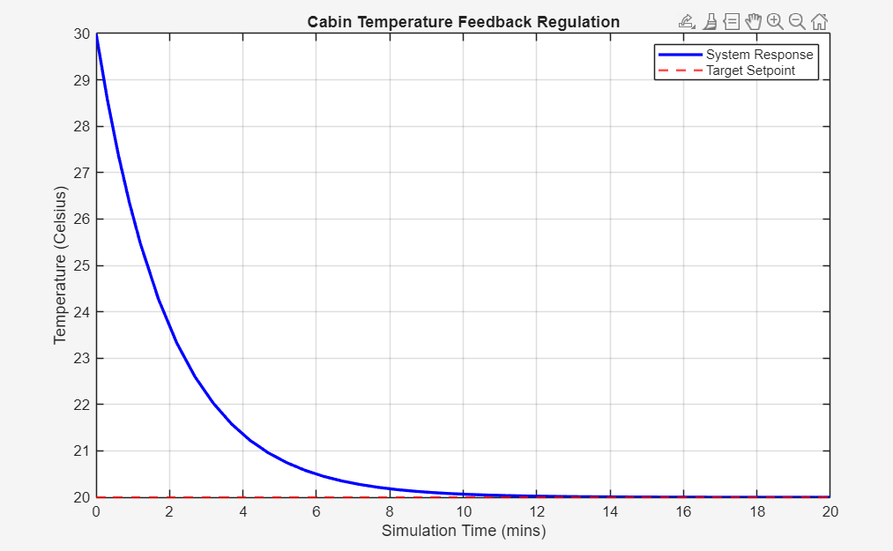
Problem 4: Aircraft Altitude Control System With Nonlinear Dynamics
Problem Statement: A small UAV altitude controller is modeled with nonlinear dynamics involving vertical velocity, gravity, upward thrust, and a nonlinear drag force (c*v*|v|).
Tasks: Simulate UAV motion for 20 seconds using ODE45. Plot altitude versus time and compare the flight trajectory between 'Without drag' and 'With nonlinear drag'.
MATLAB Implementation Code:
clc; clear; close all;

% UAV Altitude Controller (Nonlinear Dynamics)
gravity = 9.81; % Gravity acceleration (m/s^2)
drag_coeff = 0.05; % Nonlinear drag constant (c)
thrust_cmd = 15.0; % Upward thrust (u)

% Initial State: [Altitude; Velocity]
state_0 = [0; 0];

sim_time = [0 20]; % 20 seconds simulation

% Solve ODE with Nonlinear Drag
[t_drag, state_drag] = ode45(@(t, x) uav_dynamics(t, x, thrust_cmd, gravity, drag_coeff), sim_time, state_0);
alt_drag = state_drag(:, 1);
vel_drag = state_drag(:, 2);

% Solve ODE Without Drag (c = 0)
[t_nodrag, state_nodrag] = ode45(@(t, x) uav_dynamics(t, x, thrust_cmd, gravity, 0), sim_time, state_0);
alt_nodrag = state_nodrag(:, 1);

% Plot 1: Altitude Comparison
figure('Name', 'Altitude Tracking');
plot(t_drag, alt_drag, 'b', 'LineWidth', 2);
hold on;
plot(t_nodrag, alt_nodrag, 'r--', 'LineWidth', 2);
grid on;
xlabel('Time (s)');
ylabel('Altitude (m)');
title('UAV Altitude: Drag vs No Drag');
legend('With Aerodynamic Drag', 'Ideal (No Drag)', 'Location', 'northwest');

% Plot 2: Velocity Profile
figure('Name', 'Velocity Profile');
plot(t_drag, vel_drag, 'g', 'LineWidth', 2);
grid on;
xlabel('Time (s)');
ylabel('Vertical Speed (m/s)');
title('UAV Climb Velocity (With Drag)');

% Dynamics Function Definition
function dx_dt = uav_dynamics(~, state, u, g, c)
h = state(1); % current altitude
v = state(2); % current velocity

h_dot = v;
v_dot = u - g - (c * v * abs(v)); % nonlinear drag term

dx_dt = [h_dot; v_dot];
end
Simulation Output (Graphs Output):


